

# 

### Semester One Examination, 2017

### Question/Answer booklet

# MATHEMATICS

**SOLUTIONS**

**APPLICATIONS**

**UNIT 3**

## Section Two:

## Calculator-assumed

|  |  |  |  |  |  |  |  |  |  |  |
| --- | --- | --- | --- | --- | --- | --- | --- | --- | --- | --- |
| Student Number: In figures |  |  |  |  |  |  |  |  |  |  |

In words

Your name

## Time allowed for this section

Reading time before commencing work: ten minutes

Working time: one hundred minutes

## Materials required/recommended for this section

***To be provided by the supervisor***

This Question/Answer booklet

Formula sheet (retained from Section One)

***To be provided by the candidate***

Standard items: pens (blue/black preferred), pencils (including coloured), sharpener, correction fluid/tape, eraser, ruler, highlighters

Special items: drawing instruments, templates, notes on two unfolded sheets of A4 paper, and up to three calculators approved for use in this examination

## Important note to candidates

No other items may be taken into the examination room. It is **your** responsibility to ensure that you do not have any unauthorised material. If you have any unauthorised material with you, hand it to the supervisor **before** reading any further.

## Structure of this paper

|  |  |  |  |  |  |
| --- | --- | --- | --- | --- | --- |
| Section | Number of questions available | Number of questions to be answered | Working  time (minutes) | Marks available | Percentage of examination |
| Section One:  Calculator-free | 7 | 7 | 50 | 52 | 35 |
| Section Two:  Calculator-assumed | 11 | 11 | 100 | 98 | 65 |
|  | | |  | **Total** | 100 |

## Instructions to candidates

1. The rules for the conduct of examinations are detailed in the school handbook. Sitting this examination implies that you agree to abide by these rules.

2. Write your answers in this Question/Answer booklet.

3. You must be careful to confine your response to the specific question asked and to follow any instructions that are specified to a particular question.

4. Additional working space pages at the end of this Question/Answer booklet are for planning or continuing an answer. If you use these pages, indicate at the original answer, the page number it is planned/continued on and write the question number being planned/continued on the additional working space page.

5. Show all your working clearly. Your working should be in sufficient detail to allow your answers to be checked readily and for marks to be awarded for reasoning. Incorrect answers given without supporting reasoning cannot be allocated any marks. For any question or part question worth more than two marks, valid working or justification is required to receive full marks. If you repeat any question, ensure that you cancel the answer you do not wish to have marked.

6. It is recommended that you do not use pencil, except in diagrams.

7. The Formula sheet is not to be handed in with your Question/Answer booklet.

Section Two: Calculator-assumed 65% (98 Marks)

This section has**eleven (****11)** questions. Answer **all** questions. Write your answers in the spaces provided.

Working time: 100 minutes.

Question 8 (6 marks)

The weight, kg, of flour produced by a mill that needs to be sent to the packing department is given by , where is the number of minutes after 5 am.

(a) Complete the table below. (2 marks)

|  |  |  |  |  |  |  |
| --- | --- | --- | --- | --- | --- | --- |
|  |  |  |  |  |  |  |
|  |  | **8.75** | **10** | **11.25** | **12.5** | **13.75** |

|  |
| --- |
| **Solution** |
| See table |
| **Specific behaviours** |
| ✓ at least three values correct  ✓ all values correct |

(b) Calculate the weight of flour at 6 am. (2 marks)

|  |
| --- |
| **Solution** |
|  |
| **Specific behaviours** |
| ✓ identifies  ✓ states value |

(c) At what time will the weight of flour reach 150 kg? (2 marks)

|  |
| --- |
| **Solution** |
|  |
| **Specific behaviours** |
| ✓ identifies  ✓ states time |

Question 9 (13 marks)

Agricultural researchers collected data on the amount of rainfall ( mm) and the yield of cucumbers ( kg per square metre) over several seasons at a farm. Some of their data is shown in the table and scatterplot below.

|  |  |  |  |  |  |  |  |  |  |  |  |  |
| --- | --- | --- | --- | --- | --- | --- | --- | --- | --- | --- | --- | --- |
| Rainfall, | 22 | 84 | 97 | 48 | 14 | 37 | 97 | 50 | 61 | 75 | 36 | 6 |
| Yield, | 0.36 | 0.72 | 0.66 | 0.21 | 0.11 | 0.54 | 0.66 | 0.56 | 0.42 | 0.61 | 0.31 | 0.09 |

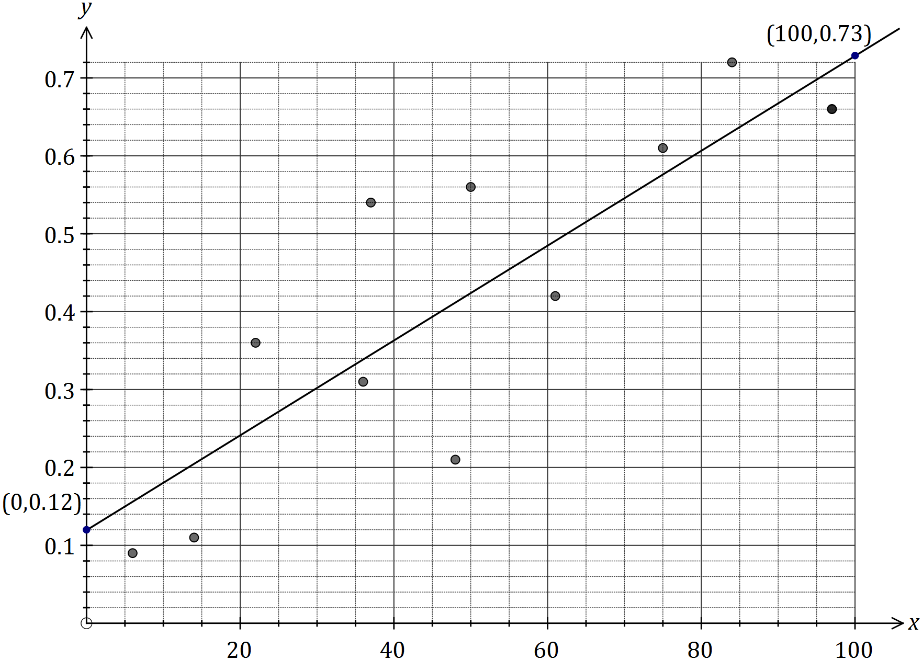

(a) Calculate the correlation coefficient for the data, and comment on how its value is reflected in the scatterplot above. (3 marks)

|  |
| --- |
| **Solution** |
| Strong positive value is reflected in increasing trend shown by points. |
| **Specific behaviours** |
| ✓ value that rounds to 0.86  ✓ indicates direction of association |

(b) What percentage of the variation in the yield can be explained by the variation in the rainfall? (2 marks)

|  |
| --- |
| **Solution** |
| Approximately 74%. |
| **Specific behaviours** |
| ✓ indicates use of coefficient of determination  ✓ states correct percentage |

(c) Determine the equation for the least-squares line that models the data. (2 marks)

|  |
| --- |
| **Solution** |
|  |
| **Specific behaviours** |
| ✓ gradient  ✓ -intercept |

(d) Draw the least-squares line on the scatterplot by first calculating two points that lie on the line. Clearly indicate these points. (3 marks)

|  |
| --- |
| **Solution** |
| Examples: (0, 0.12) and (100, 0.73)  See graph for line. |
| **Specific behaviours** |
| ✓ clearly shows two points that are not close together  ✓ line through calculated points  ✓ correct line, very close to (0, 0.12) and (100, 0.73) |

(e) Estimate the cucumber yield in a season that has 64 mm of rainfall and comment on the reliability of this value. (3 marks)

|  |
| --- |
| **Solution** |
| Estimate is reliable as correlation is strong and involves interpolation. |
| **Specific behaviours** |
| ✓ value that rounds to 0.51  ✓ considers correlation  ✓ considers interpolation |

Question 10 (7 marks)

The weighted graph below represents the footpaths connecting 12 buildings in the grounds of a defence force training facility. The number on each edge is the time required to walk along each footpath in minutes.

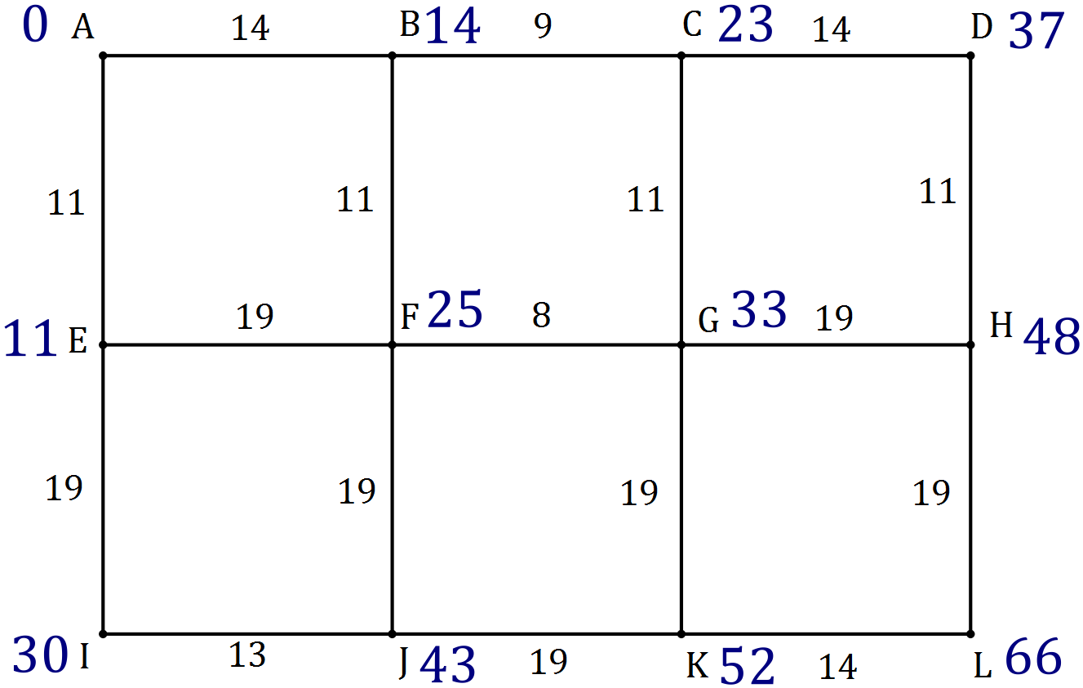

(a) Determine the minimum time to walk from to and state the corresponding route.

(2 marks)

|  |
| --- |
| **Solution** |
|  |
| **Specific behaviours** |
| ✓ total time  ✓ list of vertices |

(b) Determine the minimum time to walk from to and state the corresponding route.

(3 marks)

|  |
| --- |
| **Solution** |
| Using trial-and-error from towards and recording intermediate times, shortest time is 66 minutes.  The route is |
| **Specific behaviours** |
| ✓ records intermediate times on diagram  ✓ correct shortest time  ✓ correct listing of route |

(c) A new footpath is being planned between and so that the time to walk from to is reduced by 5 minutes. How long should the walk between and take to achieve this? Justify your answer. (2 marks)

|  |
| --- |
| **Solution** |
|  |
| **Specific behaviours** |
| ✓ explanation or equation  ✓ correct time |

Question 11 (9 marks)

The value of a machine used in a factory is recorded at the start of each year.

|  |  |  |  |
| --- | --- | --- | --- |
| Year | 2014 | 2015 | 2016 |
| Value of machine ($) | 6 875 | 5 500 | 4 400 |

(a) Explain why the three values in the table form a geometric sequence. (2 marks)

|  |
| --- |
| **Solution** |
|  |
| **Specific behaviours** |
| ✓ shows both pairs of terms have same ratio  ✓ explains nature of geometric sequence |

(b) What is the annual percentage rate of depreciation of the machine? (1 mark)

|  |
| --- |
| **Solution** |
| 20% |
| **Specific behaviours** |
| ✓ rate as percentage |

Assume that the machine continues to depreciate at the same rate.

(c) Determine a rule for , the value of the machine years after 2014. (2 marks)

|  |
| --- |
| **Solution** |
|  |
| **Specific behaviours** |
| ✓ uses th term form  ✓ uses correct coefficients |

(d) Determine the value of the machine at the start of the year 2020. (2 marks)

|  |
| --- |
| **Solution** |
|  |
| **Specific behaviours** |
| ✓ substitutes correct value of  ✓ states value |

(e) The machine will be replaced when its value at the start of the year falls below $500. Determine which year this will be. (2 marks)

|  |
| --- |
| **Solution** |
|  |
| **Specific behaviours** |
| ✓ calculates  ✓ states year |

Question 12 (11 marks)

In a recent study of artists who asked for a piece of their work to be included in an exhibition, each artist was classified by the variables (i) the state they worked in and (ii) whether their piece of work was accepted by the judges.

The table below shows the number of artists in each category.

|  |  |  |  |  |  |  |
| --- | --- | --- | --- | --- | --- | --- |
|  | State | NSW | VIC | QLD | WA | Total |
| Work accepted? | Yes | 8 | 27 | 21 | 8 | 64 |
| No | 108 | 86 | 143 | 39 | 376 |
|  | Total | 116 | 113 | 164 | 47 | 440 |

(a) Complete the missing values and totals in the table above. (4 marks)

|  |
| --- |
| **Solution** |
| See table |
| **Specific behaviours** |
| ✓ QLD Yes, ✓ Total No, ✓ NSW No, ✓ Totals |

(b) To identify the presence of an association between these two variables, explain why the state the artist worked in should be used as the explanatory variable. (2 marks)

|  |
| --- |
| **Solution** |
| It is possible for the 'state' to affect 'having work accepted', but not possible for 'having work accepted' to affect 'state artist works in'. Hence 'state' is explanatory variable and 'work accepted' is response variable. |
| **Specific behaviours** |
| ✓ reasonable argument using just explanatory variable  ✓ discussion using both explanatory and response variables |

(c) Rounding percentages to the nearest whole number, complete the percentaged two-way table below so that it may be used to identify the presence of an association between the categorical variables. (3 marks)

|  |  |  |  |  |  |
| --- | --- | --- | --- | --- | --- |
|  | State | NSW | VIC | QLD | WA |
| Work accepted? | Yes | 7% | 24% | 13% | 17% |
| No | 93% | 76% | 87% | 83% |

|  |
| --- |
| **Solution** |
| See table |
| **Specific behaviours** |
| ✓ NSW Yes  ✓ one column correct  ✓ all columns correct |

(d) Comment on the presence of an association between the two variables. (2 marks)

|  |
| --- |
| **Solution** |
| An association clearly exists, as artists from VIC (24%) are much more likely to have their work chosen than an artist from NSW (7%), QLD (13%) or WA (17%). |
| **Specific behaviours** |
| ✓ states association exists  ✓ explains reasoning |

Question 13 (8 marks)

A simple connected graph is drawn below.

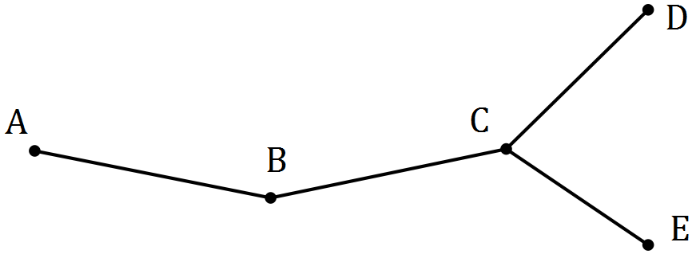

(a) List, in order, the vertices of a closed walk on the graph of length 8 that visits all vertices and ends at A.

|  |
| --- |
| **Solution** |
|  |
| **Specific behaviours** |
| ✓ starts and finishes at A  ✓ sequential walk of length 8 |

(2 marks)

(b) Explain why the walk in (a) is not a Hamiltonian cycle. (2 marks)

|  |
| --- |
| **Solution** |
| A Hamiltonian cycle is a closed path that visits every vertex other than start exactly once.  Walk in (a) visits several vertices more than once. |
| **Specific behaviours** |
| ✓ indicates both properties of Hamiltonian cycle  ✓ explains multiple vertices |

(c) Add one edge and one face to the copy of the graph below, so that the new graph contains a Hamiltonian path and mark this path on the graph. (2 marks)

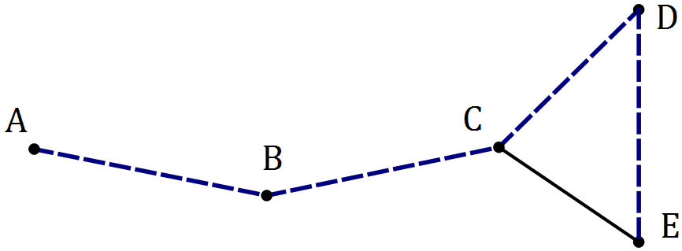

|  |
| --- |
| **Solution** |
| See graph - many solns |
| **Specific behaviours** |
| ✓ adds edge and face  ✓ marks path |

(d) Add two edges and two faces to the copy of the graph below, so that the new graph does not contain a Hamiltonian path or cycle. (2 marks)

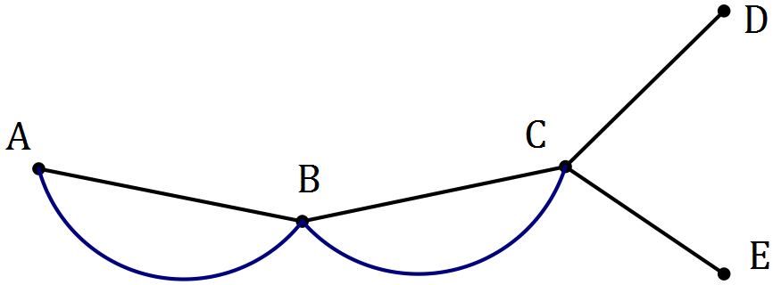

|  |
| --- |
| **Solution** |
| See graph - many solns |
| **Specific behaviours** |
| ✓ adds edges and faces  ✓ still no HP or HC |

Question 14 (6 marks)

A student was trying to decide whether fitting a linear model to their data was an appropriate choice. They calculated the least-squares line through the 30 points to be and the correlation coefficient .

(a) Explain why constructing a residual plot would help the student decide. (2 marks)

|  |
| --- |
| **Solution** |
| The residual plot will enable the student to see if any general pattern is evident in the residuals - if there is, the model will not be appropriate, but otherwise model is usually valid. |
| **Specific behaviours** |
| ✓ indicates looking for pattern in residuals  ✓ explains outcomes associated with pattern |

The residual plot for the student's data is shown below.

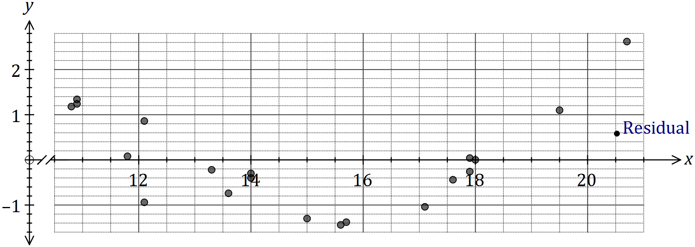

(b) One residual is missing from the plot, corresponding to the original data point .

Calculate the residual for this point and add it to the residual plot. (3 marks)

|  |
| --- |
| **Solution** |
|  |
| **Specific behaviours** |
| ✓ calculates  ✓ calculates residual  ✓ plots point |

(c) What conclusion should the student draw about the appropriateness of the linear model?

(1 mark)

|  |
| --- |
| **Solution** |
| Pattern evident so linear model not appropriate. |
| **Specific behaviours** |
| ✓ states not appropriate |

Question 15 (9 marks)

The graph below represents 14 canals that meet at locations to .

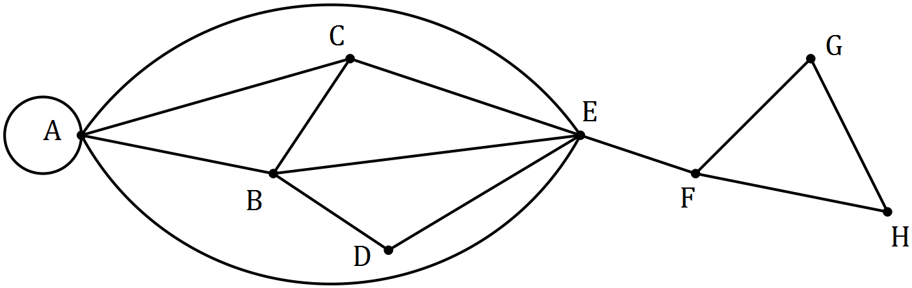

(a) A canal enthusiast noticed that the graph contained a semi-Eulerian trail. State the two properties of a walk that make a semi-Eulerian trail. (2 marks)

|  |
| --- |
| **Solution** |
| Trail is open (start and end at different vertices) and includes every edge once. |
| **Specific behaviours** |
| ✓ indicates open  ✓ indicates includes all edges |

(b) What property of a connected graph indicates the existence of a Eulerian trail, a semi-Eulerian trail or neither? (2 marks)

|  |
| --- |
| **Solution** |
| The number of odd vertices.  Eulerian has none, semi-Eulerian has 2, and neither has 4 or more. |
| **Specific behaviours** |
| ✓ indicates number of odd vertices  ✓ explains all three cases |

(c) Suggest a suitable starting point for the canal enthusiast to begin a semi-Eulerian trail and indicate where they will finish the trail. (2 marks)

|  |
| --- |
| **Solution** |
| Start , finish or other way around. |
| **Specific behaviours** |
| ✓ starting point  ✓ finish point |

(d) Draw a subgraph of the above graph that is simple, connected, has no bridges and has 8 edges. (3 marks)

|  |
| --- |
| **Solution** |
|  |
| **Specific behaviours** |
| ✓ removes RHS including bridge  ✓ removes loop and one of edges  ✓ subgraph with 8 edges |

Question 16 (9 marks)

Following the analysis of data collected from a group of women aged between 22 and 38, a strong, linear relationship between their age (, in years) and percentage chance of conception (, percent) in any given month was observed. The coefficient of determination between the variables was 0.87 and the equation of the least-squares line was .

(a) Determine the correlation coefficient between and . (2 marks)

|  |
| --- |
| **Solution** |
|  |
| **Specific behaviours** |
| ✓ determines value  ✓ determines sign |

(b) Estimate the monthly percentage chance of conception of a woman aged

(i) 18 years. (1 mark)

|  |
| --- |
| **Solution** |
|  |
| **Specific behaviours** |
| ✓ states value |

(ii) 35 years. (1 mark)

|  |
| --- |
| **Solution** |
|  |
| **Specific behaviours** |
| ✓ states value |

(c) Comment, with reasoning, on the reliability of each of your estimates in (b). (3 marks)

|  |
| --- |
| **Solution** |
| (i) is unreliable, as involves extrapolation.  (ii) is reliable, as interpolation and correlation is strong. |
| **Specific behaviours** |
| ✓ indicates (i) unreliable (ii) reliable  ✓ reason for (i)  ✓ reason for (ii) |

(d) Describe the meaning of the slope of the least-squares lines in the context of this question. (2 marks)

|  |
| --- |
| **Solution** |
| For each year a woman in the group ages, so their percentage chance of conception decreases by 0.88%. |
| **Specific behaviours** |
| ✓ indicates as age increases, % chance decreases  ✓ quantifies change with units |

Question 17 (12 marks)

As part of a trial to reintroduce woylies (an endangered species of mammals) to a wildlife reserve, researchers modelled the expected size of a woylie population, , using the rule below where is the number of months since the trial began.

(a) State

(i) the size of the woylie population at the start of the trial. (1 mark)

|  |
| --- |
| **Solution** |
| 20 woylies |
| **Specific behaviours** |
| ✓ states value |

(ii) the number of woylies added to the reserve each month. (1 mark)

|  |
| --- |
| **Solution** |
| 30 woylies |
| **Specific behaviours** |
| ✓ states value |

(iii) the percentage loss of existing woylies in the reserve each month. (1 mark)

|  |
| --- |
| **Solution** |
| 15% loss |
| **Specific behaviours** |
| ✓ states percentage |

(b) Complete the missing values in the table below to show the expected number of woylies over the first six months. (2 marks)

|  |  |  |  |  |  |  |  |
| --- | --- | --- | --- | --- | --- | --- | --- |
|  | 0 | 1 | 2 | 3 | 4 | 5 | 6 |
|  | **20** | **47** | 70 | 89 | 106 | **120** | **132** |

|  |
| --- |
| **Solution** |
| See table |
| **Specific behaviours** |
| ✓ values for  ✓ values for rounded to whole number |

(c) Determine the expected size of the woylie population after three years. (2 marks)

|  |
| --- |
| **Solution** |
|  |
| **Specific behaviours** |
| ✓ indicates use of  ✓ states rounded value |

(d) Graph the population of woylies on the axes below for . (3 marks)

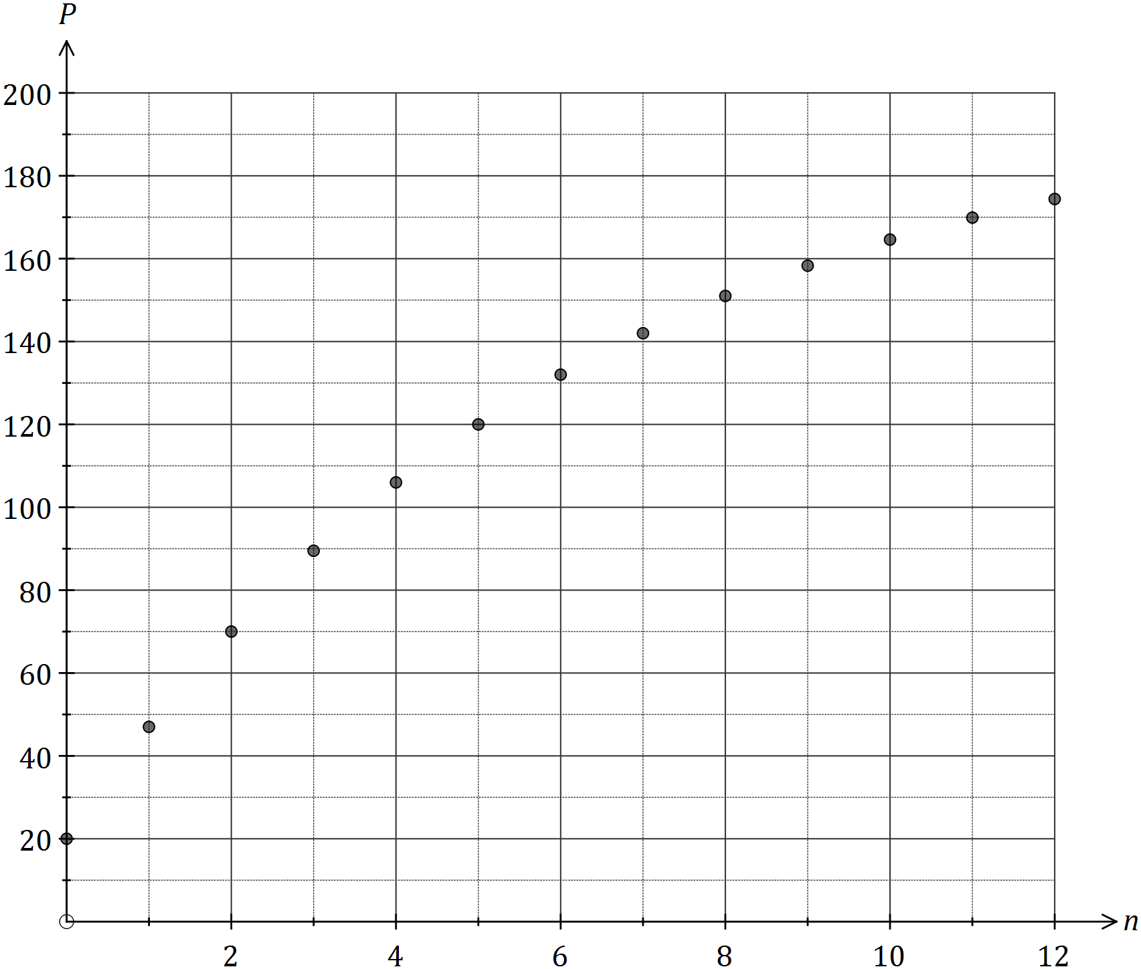

|  |
| --- |
| **Solution** |
| See graph |
| **Specific behaviours** |
| ✓ at least half of points accurately plotted  ✓ all points accurately plotted  ✓ just points, as not steady, continuous growth |

(e) Use the model to describe how the size of the woylie population in the reserve will change over the first three years. (2 marks)

|  |
| --- |
| **Solution** |
| Population will increase rapidly at the start, but then level out at close to 200 woylies after two years. |
| **Specific behaviours** |
| ✓ indicates rapid increase at start  ✓ indicates steady state after two years |

Question 18 (8 marks)

Five children () are playing a game of hide and seek. The directed edges, shown in the adjacency matrix below, represent whether the child in a row knows the location of the child in a column.

|  |  |  |  |  |  |
| --- | --- | --- | --- | --- | --- |
|  |  |  |  |  |  |
|  | 0 | 1 | 1 | 0 | 0 |
|  | 0 | 0 | 1 | 0 | 1 |
|  | 0 | 0 | 0 | 1 | 1 |
|  | 1 | 1 | 0 | 0 | 0 |
|  | 0 | 0 | 0 | 1 | 0 |

(a) Construct a digraph to show the above information. (3 marks)

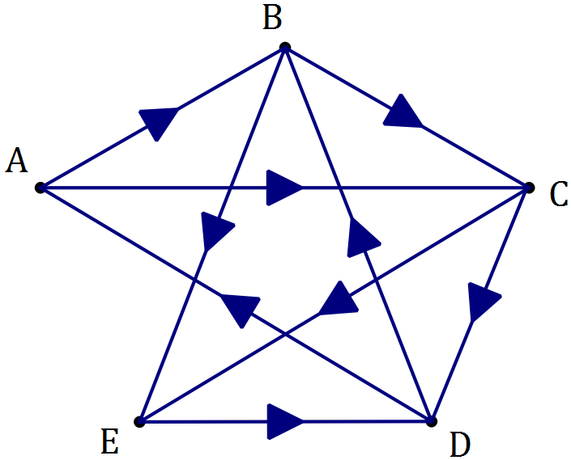

|  |
| --- |
| **Solution** |
| See graph |
| **Specific behaviours** |
| ✓ all edges  ✓ at least 7 directions correct  ✓ all directions correct |

(b) Calculate the matrix . (1 mark)

|  |
| --- |
| **Solution** |
|  |
| **Specific behaviours** |
| ✓ calculates correctly |

(c) If child wanted to locate child with the help of one other child, could they? Explain how an element of can help justify your answer. (2 marks)

|  |
| --- |
| **Solution** |
| Yes.  means they can find out through another child (). |
| **Specific behaviours** |
| ✓ states yes  ✓ explanation involving |

(d) Two children are unable to locate all the other children, even with the help of one other child. Who are these two, and who can't they locate? (2 marks)

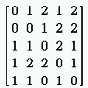

|  |
| --- |
| **Solution** |
| can't locate  can't locate  *(0 elements except diagonal in )* |
| **Specific behaviours** |
| ✓ identifies first pair  ✓ identifies second pair |

Additional working space

Question number: _________

Additional working space

Question number: _________

Additional working space

Question number: _________

© 2016 WA Exam Papers. Mercedes College has a non-exclusive licence to copy and communicate this paper for non-commercial, educational use within the school. No other copying, communication or use is permitted without the express written permission of WA Exam Papers. SN064-096-4.